Fundraising Appeal
Mattole Valley Resource Center Endowment Fund
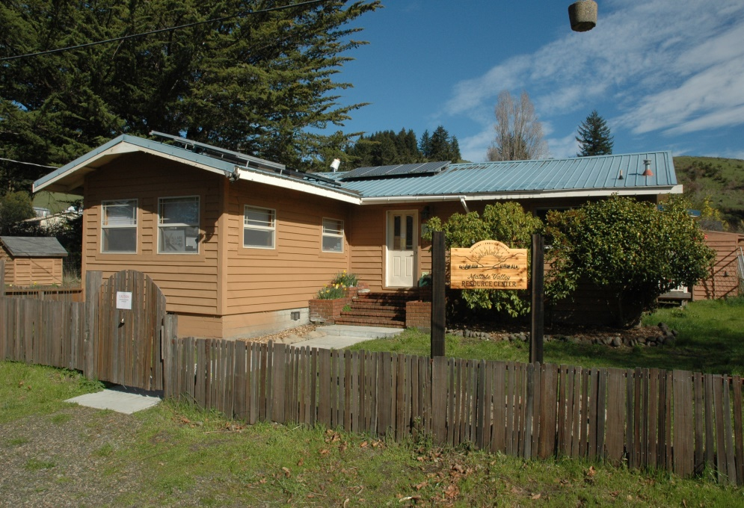

The Mattole Valley Resource Center (MVRC) is a community based, 501(c)(3) non-profit that provides social services in the lower Mattole Valley (summarized on p. 2; also see https://mattolevalleyresourcecenter.org/). Several years ago, Ken Young, a remarkable Petrolia resident, left his house to the MVRC. We secured grant funding to make the house an attractive and accessible facility; besides our office, there is space for exercise classes and other activities, a counseling room, and a playground. This will allow us to expand our services once Covid-19 restrictions are past; for example, we hope to house a part-time medical clinic. However, we are now faced with the on-going expenses associated with home ownership. Grant funding for such expenses is hard to come by, so with an initial anonymous donation of $10,000 and about $10,000 worth of silver from Ken, we have established an endowment fund, to be managed by the Humboldt Area Foundation, which currently manages money for over 100 local non-profits. This fund will generate income that will be applied to the house expenses; income beyond that needed for these expenses will be re-invested or applied to MVRC programs. We are now seeking additional donations to the fund, with a target of $100,000.

The need and the services:
The Mattole Valley is a wonderful place to live, but has its share of rural poverty, social isolation, and associated problems, affecting especially children, seniors, and those in poor mental or physical health. With an annual budget of about $140,000, >90% from government or foundation grants, the MVRC helps to address these problems with programs that aim to build community and help people lead healthier, more connected, and more productive lives. The programs generally serve multiple purposes. For example, play groups for children help socialize children, but also give parents or caregivers a chance to visit, share guidance on parenting, and build relationships with parents or caregivers who may need other services or support. The MVRC’s programs include:
Food security: the MVRC food pantry regularly delivers food to eligible residents, mostly seniors, provides holiday food baskets and gifts, and helps people sign up for programs such as CalFresh (food stamps). It also provides emergency food for people in crisis.
Health care/wellness: the MVRC helps people sign up for Medi-Cal or ACA health insurance, and coordinates with local health services, including the Open Door Clinic and the Redwoods Rural Dental Van. It offers counseling referrals, substance abuse and other counseling and support; and sponsors classes including first aid and CPR, self-care for new parents, low impact exercise for seniors, self-defense for women, and more. It assists a local mental health and wellness program for black, indigenous or people of color.
Employment: The MVRC offers help with resume writing and office support for job seekers, and helps people apply for unemployment. It coordinates training for licensed child care provider, pediatric CPR and first aid, in-home health service certification.
Referrals: The MVRC helps people find others kinds of services, such as legal aid.
Youth: the MVRC sponsors play groups, sports programs, and after school enrichment programs. The staff makes home visits to families with young children.
Firewood: The MVRC provides firewood vouchers to low-income seniors.
Community events: The MVRC holds holiday parties and community meals.
Porta potties: the MVRC facilitates community support for two units, in collaboration with the Mattole Valley Community Center; these are the only public toilets in Petrolia.
Checks can be sent to the Mattole Valley Resource Center, PO Box 191, Petrolia, CA 95558. Please write Endowment Fund on the memo line, and include an address for an acknowledgement letter. This appeal is intended to serve as a “gift instrument” controlling the use of the fund. For more information, contact John Williams, MVRC treasurer, at 707 629 3265, or jgwill@frontiernet.net.

See https://www.runnersworld.com/runners-stories/a20861716/the-endless-toil-of-the-big-data-guy//
If it becomes impractical for the MVRC to continue using the house as an office, the fund may be applied to other MVRC programs, or passed on to a similar 501(c)(3) organization.

